1.
List three real-life scenarios where a multimeter would be used to troubleshoot a computer or smartphone issue, and explain in one line how the multimeter helps in each case.
- Laptop won’t power on : Measure DC voltage across battery terminals — confirms if the battery is dead or charging circuit is faulty.
- Smartphone charging issue : Use continuity mode on charging port pins — detects broken traces or lifted pads.
- PC short circuit suspicion : Measure resistance on motherboard power rails.

2.
Watch a short YouTube video demo of a POST card in action (search for 'POST card motherboard test'), then write a brief summary (3-4 lines) describing what the POST card displays and what problem it helped identify in the video.<br><br><em><strong>Hint:</strong> Focus on the codes shown and how they relate to hardware issues.</em>
In the YouTube demo, the POST card displayed hexadecimal codes on its 7-segment LED during motherboard startup. Each code corresponded to a hardware initialization step. The card froze at a specific code, which indicated a RAM training failure , helping the technician quickly identify that the memory module was the root cause of the boot issue.

3.
Download and install any free software diagnostic tool (such as HWMonitor, Speccy, or CrystalDiskInfo), run it on your laptop or desktop, and take a screenshot of the main dashboard showing system health details.<br><br><em><strong>Constraint:</strong> Blur or crop out any personal information before submitting.</em>
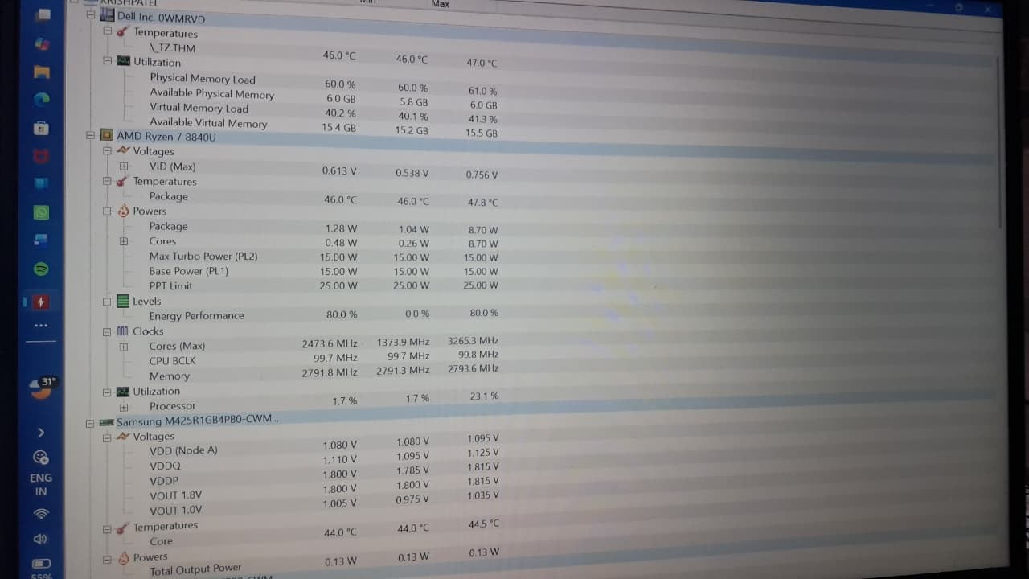

4.
Compare the use of a multimeter, POST card, and software diagnostics by creating a table with three columns (Tool, What it checks, Example Problem Detected) and fill in at least one example for each tool.
Tool | What it Checks | Example Problem Detected
Multimeter | Voltage, resistance, continuity on circuits | Dead battery, shorted power rail
POST Card | Motherboard boot sequence codes | RAM failure preventing POST
Software Diagnostics | System health (temps, voltages, disk status) | Overheating CPU, failing hard drive

